|  |  |
| --- | --- |
| **Exponent Rule** | **Example** |
|  |  |
|  |  |
|  |  |
|  |  |
|  |  |
|  |  |
|  |  |
|  |  |

|  |  |
| --- | --- |
|  |  |
|  |  |
|  |  |
|  |  |
|  |  |
|  |  |
|  |  |

|  |
| --- |
|  |
| ? |
|  |
|  |
|  |
|  |
|  |
|  |
|  |
| **?**  **?** |
| **?** |
|  |

**Exercise A:**

1. If $x = 4^{20}+4^{21}+4^{22}$, what is the largest prime factor of $x?$
2. If $x^{4}.x^{-4}=y$, then what is y?
3. If $x^{3}-x=0$ and $x^{2}+x^{2}=2$, what is x?
4. Which is bigger ${\left(\frac{3}{4}\right)}^{2}$ or ${\left(0.8\right)}^{2}$?
5. Which is bigger ${\left(\frac{10}{7}\right)}^{2}$ or $\frac{10}{7}$?
6. ${\left(\frac{1}{2}\right)}^{y}=\frac{1}{4}{×2}^{y}$, what is y?
7. $\frac{5^{y+2}}{5^{3}}=1$, what is y?
${2.2}^{x}=16, what is x?$

9. Quantity A $:2^{y}$

Quantity B: ${\left(\frac{1}{2}\right)}^{-y}$

1. Quantity A $:3^{3}.9^{6}.2^{4}{.4}^{2}$

Quantity B: $9^{3}3^{6}2^{2}4^{4}$

1. Quantity A $:{0.99}^{y}$

Quantity B: $0.99y$

1. Quantity A $:\frac{0.918}{{0.91}^{91}}$

Quantity B: $0.918$

1. If x =2, the value of ${\left(x^{2}\right)}^{3} +x$ is?
2. Quantity A $:{\left(4^{2}\right)}^{3}-4^{3}$

Quantity B: ${\left(4^{3}\right)}^{2}-4^{2}$

1. Quantity A $:{\left(7^{21}+7^{-21}\right)}^{2}$

Quantity B: $7^{42}+7^{-42}$

1. Simplify $\frac{a{\left(a^{2}\right)}^{-1}}{a^{-1}}$
2. If $3^{2a}{11}^{b}={27}^{4x}{33}^{2x}$, then x must be equal to?
3. The quantity $3^{3}4^{4}5^{5}6^{6}-3^{6}4^{5}5^{4}6^{3}$ will end up in how many zeroes?
4. x is a positive odd integer

Quantity A: ${\left(-3\right)}^{x}$

Quantity B: $-2^{2x}$

1. x and y are positive integers such that x < y. If $6\sqrt{6}=x\sqrt{y}$ = , then xy could equal
2. 36
3. 48
4. 54
5. 96
6. 108
7. 36<x<49

Quantity A: $2^{\sqrt{x}}$

Quantity B: $4^{3}$

1. Quantity A: $\frac{\sqrt{6}\sqrt{18}}{\sqrt{9}}$

Quantity B: $\frac{\sqrt{8}\sqrt{12}}{\sqrt{6}}$

1. If $4^{n} + 4^{n} + 4^{n} + 4^{n} = 4^{16}$, then n =
2. If ${\left(-\frac{1}{2}\right)}^{N}>-8$, which of the following could be the value of N?
3. -10
4. -7
5. -3
6. 0
7. 3
8. 10
9. If -1 < x < 0, which of the following is correct?
$x^{-1} < x^{-2} < x^{-3}$

$x^{-3} < x^{-2} < x^{-1}$

$x^{-1} < x^{-3} < x^{-2}$

$x^{-2} < x^{-3} < x^{-1 }$

$x^{-3} < x^{-1} < x^{-2}$

10. Which of the following are equal to ${\left(\frac{1}{560}\right)}^{-4}?$ Indicate all correct answers.
$\frac{{560}^{5}-{560}^{4}}{559}$

$\frac{{560}^{-8}}{{560}^{2}}$

${70}^{4}{\left(\frac{1}{8}\right)}^{-4}$

$\sqrt{{560}^{16}}$

11. If $\frac{8^{5}4^{6}}{{16}^{n}}={32}^{1-n}$ then n=
$\sqrt{0.00001}=$

$\frac{\sqrt{10}}{100}$

$\frac{1}{100}$

$\frac{\sqrt{10}}{1000}$

$\frac{1}{1000}$

$\frac{\sqrt{10}}{10000}$

12. If $2^{2n} + 2^{2n} + 2^{2n} + 2^{2n} = 4^{24}$, then n =
13. If ${\left(\frac{1}{2}\right)}^{24}{\left(\frac{1}{81}\right)}^{k}=\frac{1}{{18}^{24}}$ then k=
14. If $2^{k}=3$ then $2^{3k+2}$ =
15. If $8^{c}\sqrt{8}=\frac{8^{a}}{8^{b}}$ then a=
16. Can you simplify $\frac{2+\sqrt{2}}{2-\sqrt{2}}$ so that the denominator becomes an integer?
17. Quantity A: $\sqrt{77,777,777}$

Quantity B: 8800

1. Quantity A: $\sqrt{20+80}$

Quantity B: $\sqrt{20}+\sqrt{80}$

1. **Quantity A: $10$**

**Quantity B: $\sqrt{20}+\sqrt{80}$**

1. Simplify $\sqrt{169+81}$
2. Given that x is an integer greater than 1

Quantity A: $\sqrt{32\left(2\right)x^{2}+12(3)(x^{2})}$

Quantity B: $20$

**Exercise B**

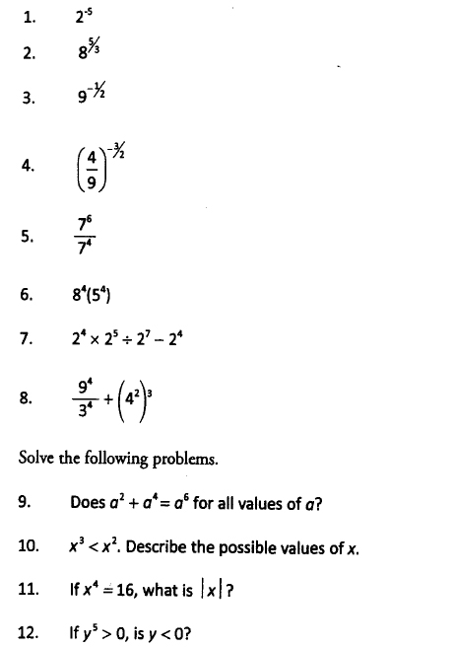

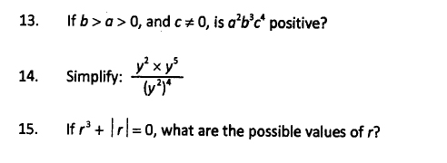

**Exercise C**

